|  |  |  |
| --- | --- | --- |
| VILNIAUS KOLEGIJA  UNIVERSITY OF APPLIED SCIENCES  FACULTY OF ELECTRONICS AND INFORMATICS  https://screenshotscdn.firefoxusercontent.com/images/eaf3f7f3-2952-4801-af5c-4f20e8ae8b88.png | | |
|  | | |
| **ECOMMERCE WEBSITE PROJECT** | | |
|  | | |
|  | | |
| GROUP WORK  6531BX028 PI18E | | |
| STUDENTS | (SIGNATURE) | EDITA KOMAROVA    DŽIUGAS PEČIULEVIČIUS |
| 2020-10 |
| (SIGNATURE) |
| 2020-10 |
|  |
|  |
|  |
| LECTURER | (SIGNATURE) | JŪRATE VAIČIULYTĖ | |
|  | 2020-10 |  |
|  |  |  |
|  | | |

Table of Contents

Introduction 3

The goal of the project 3

Client 3

Development Team members 3

Preliminary requirements 3

Description of the project plan 3

Mock up 5

Suggested deliverables 9

Visibility plan 9

Risk analysis 9

Technical requirements 9

**Table of Figures**

Figure 1- Planning phase 4

Figure 2-Designing phase 4

Figure 3- Development phase 4

Figure 4- Testing and Documentation phase 5

Figure 5- Main page 6

Figure 6- Product page 7

Figure 7-Collections page 8

Figure 8- Cart page 9

Figure 9- Login page 9

# Introduction

An e-commerce project will give us an experience of developing website. It’s includes problem specification, requirement extraction, system design, implementation, integration, testing and documentation. This project will provide us the experience working in a team and dealing with the associated problems of communication and team management.

# The goal of the project

The goal of the project is to create an ecommerce website for a business owner, that would allow to customer to see collections, buy clothes and check out entering credit card information.

# Client

A business owner who needs a website for his/her business.

# Development Team members

Project Manager – Edita Komarova

Business Analyst – Edita Komarova

Programmer - Džiugas Pečiulevičius

Tester - Džiugas Pečiulevičius

# Preliminary requirements

Functional Requirements:

1. The system should allow users to view product collections.
2. The system should allow users to add item to shopping cart.
3. The system should have Sign-in window where user can login or create an account.
4. The system should allow users to check out and buy an item only if user is logged in.
5. The system should allow users to pay for their goods using Stripe or PayPal.
6. The system should allow users to search for the product.
7. The system should allow users to read and write reviews.

Non-Functional Requirements:

1. Application should be written in JavaScript.
2. Application should use React framework.
3. The application should be hosted on Heroku.
4. The application (shop) data should be stored on Firebase or MongoDB.

# Description of the project plan

Software will be developed using Waterfall process model.    
This model has been chosen because it’s allows us to plan through every step and ensures that the project will meet our expectations and so we don’t have to come to the previous phase. Waterfall process is suitable for the team of 2.

The project was divided into Planning, Designing, Implementation Testing, and Documentation phases. The first one is Planning, this phase help us decide what kind of functional and non-functional this project would have to meet, technical requirement is needed and what kind of risks we might face it.  The second phase is Designing will include architecture description, main components of the software and static and dynamic model like use case diagram, class diagram etc. Implementation phase will include the software and what kind of tools are used to create the software. Testing phase will include a testing plan and documentation phase will include user documentation.

The project plan (Gantt chart) is given bellow:

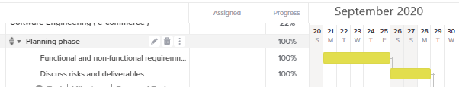

Figure 1- Planning phase

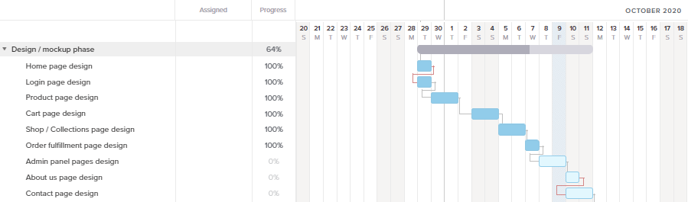

Figure 2-Designing phase

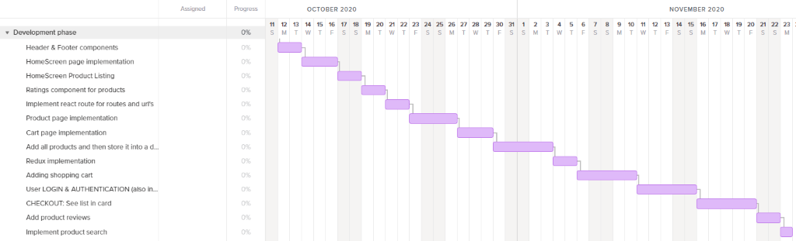

Figure 3- Development phase

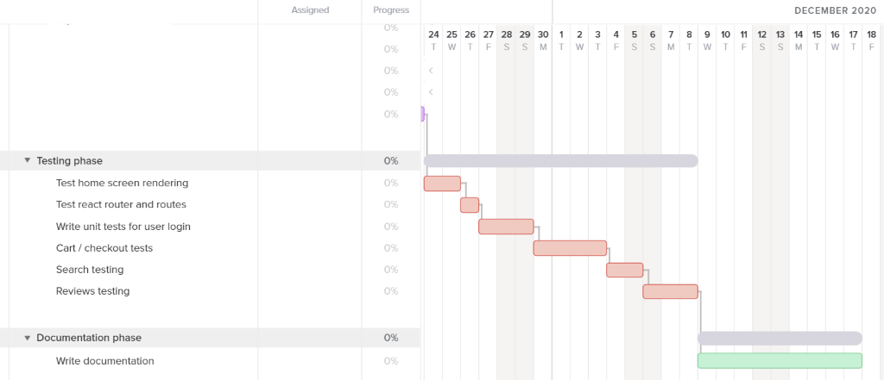

Figure 4- Testing and Documentation phase

# Mock up

Mockup made using Adobe XD

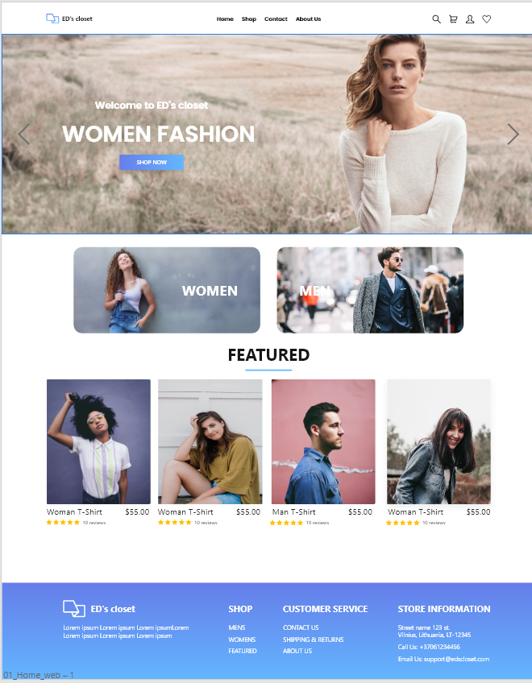

Figure 5- Main page

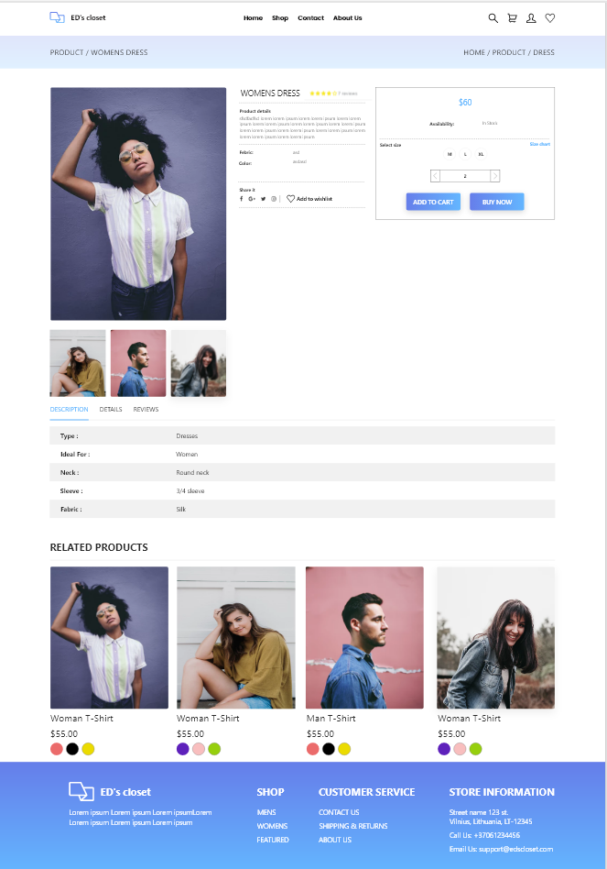

Figure 6- Product page

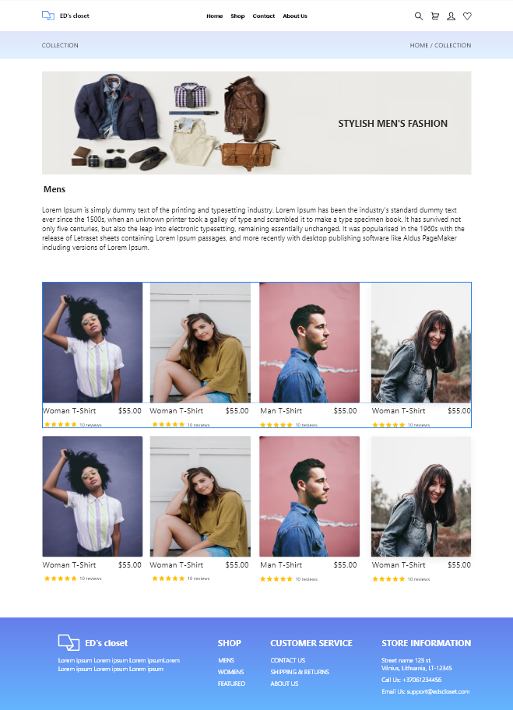

Figure 7-Collections page

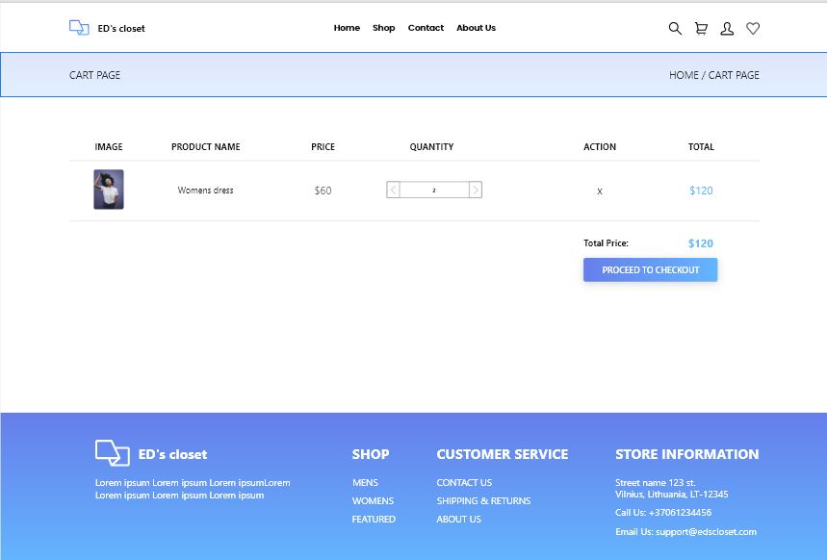

Figure 8- Cart page

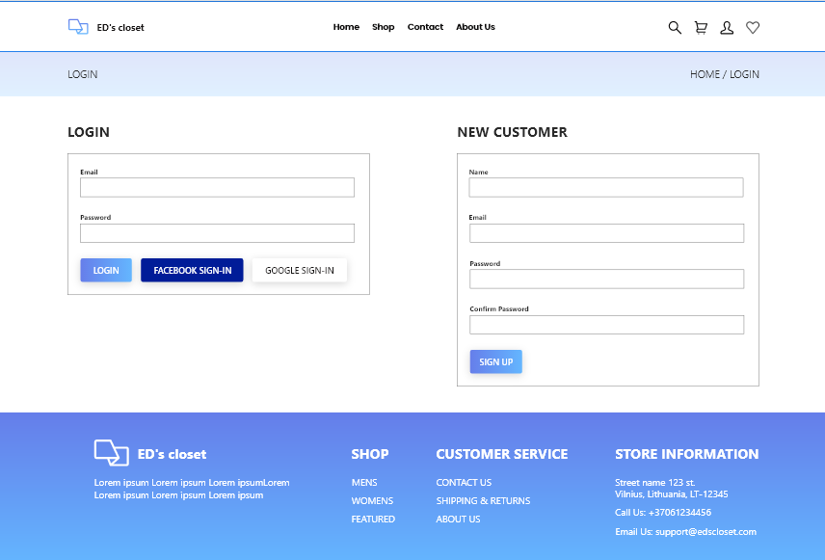

Figure 9- Login page

# Suggested deliverables

1. Working software.
2. Testing plan.
3. Documentation of the software.
4. Development plan.
5. Mock-up

# Visibility plan

The communication among team members will be done via:

1. Discord.
2. Email.
3. Live meetings.

The visibility of the project will be maintained by using:

1. GitHub git repository management.
2. OneDrive cloud storage.
3. Trello

# Risk analysis

Table 1. Risk Analysis.

|  |  |
| --- | --- |
| **Risk** | **Risk Management** |
| Team member gets sick. | Distribute the work for the remaining team members. |
| Team member will refuse to do his/her part. | Exchange the roles or renegotiate the responsibilities. |
| The members computer may stop working | Fix the computer or find a replacement. |
| The website host starts not working | Find another host to host a website. |
| The code might break | Revert to the previous version of the project. |
| The project idea might be not implementable | Change the functionality of the project if needed. |

# Technical requirements

The computer should have VS Code Editor.

Internet connection.

Headphones and microphone.

The computer should have a minimum of 4 GB of ram.